**Residential Halls Wi-Fi network Check List**

Please ensure to include ALL of the following information for any device experiencing issues. This information is required **before** we can investigate. Please answer ALL of the 13 questions.

|  |
| --- |
| 1. **Resident name** |
|  |
| 1. **Email address** |
|  |
| 1. **Mobile number** *(Include international area code as appropriate):* |
|  |
| 1. **Location** - Are you in a Family House or Flat? Building Name / Room No |
|  |
| 1. Do you have software updates waiting to be installed or pending restart on your device? If yes, please install and restart the device and try again. |
|  |
| 1. What type of device are you using? Phone, Laptop, Tablet - type, model & name of the device ( will find this under settings). |
|  |
| 1. Do you have other devices that connect? If yes what Type/OS/model of device? |
|  |
| 1. Have you connected to Eduroam Wi-Fi elsewhere? For example. Halls, Library, Grounded, Mrs O’s, Waimarie, If so please note the location. |
|  |
| 1. Has *Eduroam* worked on this device previously or is this your 1st attempt? |
|  |
| 1. Are there other users in your house/flat? If yes are they also having the same issues at the same time? |
|  |
| 1. Do you only have issues during certain times of the day?   If yes please Specify date and time (01/04/2024 at 10:15pm etc) |
|  |
| 1. For each device having issues please include the MAC addresses: (see instructions at the end of this document). |
|  |
| 1. If the issue is not only connectivity but performance (such as speed or bandwidth), please visit the following website**: http://www.speedtest.net** on each device experiencing issues. Once the test is complete, take a screen shot and paste it into this document (see more information at the end of this document) |
|  |

**How to find your MAC Address (Question 12)**

1. **For Windows Users**:

* Click the start menu > type **cmd** into the search bar
* Open **Command Prompt** > type **ipconfig /all** <enter>, take a screenshot and send it with the rest of the information requested.

1. **For Mac Users:**

* Go to Apple menu > System Preferences > Network > Wi-Fi
* Click on Advanced button on the right, and the MAC address is listed there.

1. **For iPhone users:**

* Open the Settings app  Settings icon
* Select General > About
* The Wi-Fi address is your Mac address.

1. **For Android users:**

* Go to Settings > About(phone) > Status>WiFi MAC address

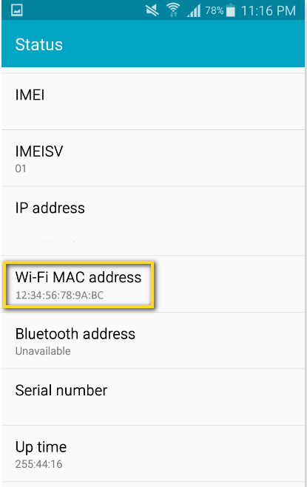

**How to do speed test. (Question 13)**

If the issue is not only connectivity but performance (speed/bandwidth) go to the following website:**http://www.speedtest.net**on each device having issues and click on **Go.**

After the test, it will measure your 'Download speed' and 'Upload speed' on that device. Once the test is complete, take a screenshot, copy it into the email, and specify which device each screenshot relates to if there is more than one device experiencing issues.

